Cyrus Information Technologies (Pvt) Ltd

# Your Technology and IT Talent Partner

A Leading IT Supplier

An Information Technology company with more than 15 year’s experience with technical consultants, Engineers and sales Professionals providing consultation and implementing high-end solutions which includes hardware, Software, Data Center, Infrastructure Solutions, IT Manage Services, software development etc. for Small, Medium and Enterprise business in Sri Lanka and globally.

Cyrus Information Technologies (Pvt) Ltd has the services of some of the best professionals in the industry who are certified and trained in Microsoft, DELL, HP, EMC, Gate Protect, CISCO, VMware, Red Hat Linux and Open Source Solutions, Etc.

100+ 2500+ 10+ 7+

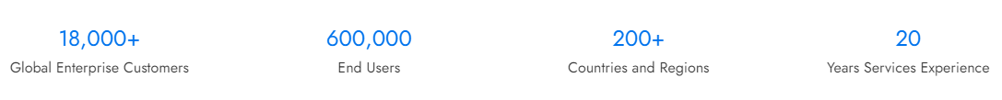

Industries We Serve

Cyrus Information Technologies (Pvt) Ltd, as a technology company, welcome customers from different industries whether you need to integrate a new software system into your infrastructure or redesign and upgrade outdated solutions. We provide customized state of art technology solutions to any type of industry.

<https://www.w3schools.com/howto/howto_css_image_grid_responsive.asp>

Retail and E-commerce

Healthcare

Education

Finance and economics

Automotive

Entertainment and Media

Technology

Manufacturing

Space and Aviation

Transportation

Telecommunication

Oil and Gas

Agriculture

About Us

An Information Technology company with more than 18 year’s of experience with technical consultants, Engineers and sales Professionals providing consultation and implementing high-end solutions which includes hardware, Software, Data Center, Infrastructure Solutions, IT Manage Services, software development etc. for Small, Medium and Enterprise business in Sri Lanka and globally.

Cyrus Information Technologies (Pvt) Ltd has the services of some of the best professionals in the industry who are certified and trained in Microsoft, DELL, HP, EMC, Gate Protect, CISCO, VMware, Red Hat Linux and Open Source Solutions, Etc.

Our global Technologies

Sliding logos

<https://www.capitalnumbers.com/?utm_source=goodfirms&utm_medium=cpc&utm_campaign=sponsorship>